AGILE PROJECT MANAGEMENT

LECTURER NAME: SIDRIT MERO

MIS608

ASSESSMENT NUMBER 3 CASE STUDY REPORT CLICK A BRICK

GROUP 8 STUDENTS

Harish Reddy Mekala A00043519

Hardik Patel A00057336

Ignacio Carreon Carrasco A00045758

Abhishek Saini A00057129

Mahesh Veldandi

Anjay Madiyal

# **Executive Summary**

The article presents the research to demonstrate an understanding of Agile concepts, tools, and practices in advance of the introduction of Master Mind Magic, a digital product. The product's target market is youngsters aged 8 to 12. In the framework of the Click-a-brick business case study, the main principles of the agile methodology are explained and demonstrated. The business case is used to demonstrate the benefits of using an agile PM approach in response to a pressing business need to develop a mobile app. The PM plan re-aligned strategies with business objectives as evidenced by developing business requirements after each quarter. In every quarter, the agile velocity burnout chart depicts the project's scope. The scrum's first sprints will represent the minimal viable product that will be released in the first quarter. In the first quarter, Master Mind Magic usually has an application created to test the user interface and game filters.

The application's next marketable product will be released in the third quarter, when augmented reality will be integrated into the gaming setup. The initial release will be a 75% finished product with registration and login functionality. The third version, on the other hand, will be a fully polished product with customer support and content production tools. The second quarter will be devoted to refining comments and suggestions based on user interface experiences. The product release will not be delayed by the end of the third quarter since one more sprint is necessary to fulfil the narrative points.

**Introduction**

The purpose of the essay is to do research in order to demonstrate a grasp of Agile principles, tools, and practices in preparation for the launch of the digital product Master Mind Magic. The target market for the product is children aged 8 to 12. The product will be an interface of real and virtual world where the players of the target consumers will be able to use their imagination to create a world if their own. The key ideas of the agile approach to develop the smartphone application will be also presented and shown in the context of the Click-a-brick business case study. The business case is used below to show the benefits of the agile PM strategy in response to a difficult business necessity for launching a mobile application. After each quarter, the PM plan re-aligned strategies with business objectives indicated by evolving business requirements. The essay also shows how during the essay preparation, the team learned about the complexity of a product launch and how to create and implement revisions based on changing and evolving business demands through reflection on the agile process. A collaborative strategy is adopted to alleviate the product's business demands while adhering to the agile methodology's standards

# **Product Vision & Road Map**

## Product Vision

The product vision provides the purpose to the product which help in selecting the correct strategy for achieving the goals of the product (Pichler, 2014). The product to be developed is the complementary to the new play set for 8-12 age set. The product is digital application known as “**Master Mind Magic**” which will help children in learning new things from the product. The product will help children in activating their imagination for creating new things.

## Product Roadmap

Product roadmap is used for outlining the vision, progress of product and direction for a time period. It is developed in accordance to the goals and objectives of the company which will help in achieving these goals (Atlassian, 2022). It should be linked with the goals and strategy of the product which can help in making changes in the product development and getting feedback from customers. The roadmap for “**Master Mind Magic**” application is:

|  |  |  |  |
| --- | --- | --- | --- |
| **Q1** | **Q2** | **Q3** | **Q4** |
| * Design of Application * Login Profile * Database creation | * Different module creation | * Testing of modules and making changes to errors detected | * Releasing beta version of application |

# **Release planning and cadence**

The release planning is based on the user stories that are identified on the user interface experience of the application. The user stories are categorically divided into two sections. The one is the customer and the other is the admin. The release planning and cadence is shared below:

## **Release plan**

|  |  |  |  |  |  |  |  |  |  |  |  |
| --- | --- | --- | --- | --- | --- | --- | --- | --- | --- | --- | --- |
| **May** | **Jun** | **July** | **Aug** | **Sept** | **Oct** | **Nov** | **Dec** | **Jan** | **Feb** | **March** | **April** |
| **Back End** | | | Front End | | | Release | | | Training | | |
| **Code Review using JIRA** | | | Design User Interface portals | | | Release app with latest support | | | Train and develop for the application launch | | |
| **Review solutions** | | | Evaluate application performance | | | Develop a support team | | | Train for customer support | | |
| **Develop user interface** | | | Allocate resources | | | Install server and testing ground | | | Develop user interface team | | |
| **Install Servers** | | | Identify user requests | | | Prepare for testing | | | Monitor reviews from each department | | |

## **Release Cadence**

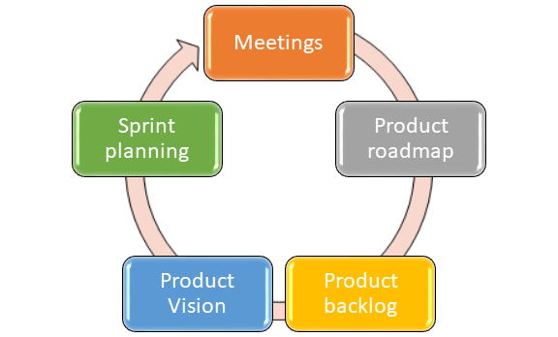

Fig (1): Release Cadence

# **Agile requirements**

Agile project management solutions are a good option for the project for Click-a-Brick to enhance the application service and boost client satisfaction. This can assist teams in developing high-quality products and services, speeding up time to market, and encouraging collaboration. The requirements of the agile project management of the application is shown below:

1. Functional requirements – Home Page, Profile page, Edit section and Search Feature
2. Nonfunctional requirements – User interface, safety features, performance indicator and easy use
3. User stories – The user stories are defined in the section below:

|  |  |
| --- | --- |
| **User** | **User story** |
| **As customer** | I want to create my profile and login |
| **As customer** | I want to use filters |
| **As customer** | I want to download and share the processed images |
| **As admin** | I want to provide filters to the customers |
| **As admin** | I want to update the legal licenses and documents of the app. |

1. Testing – The testing of the user interface and customer support will enable the team to modify and increase the user stories. The testing will also provide platforms for the consumer awareness of the application.

|  |  |  |
| --- | --- | --- |
| **User** | **User story** | **Testing** |
| **As customer** | I want to create my profile and login | Login and create a profile |
| **As customer** | I want to use filters | Upload and apply the filters offered |
| **As customer** | I want to download and share the processed images | Download the edited documents in various formats |
| **As admin** | I want to provide filters to the customers | Design and develop filters through technical department |
| **As admin** | I want to update the legal licenses and documents of the app. | Check the expiration and authenticity of the license |

# **Lean Startup Tools Used in Agile**

Lean startup methodology is the scientific approach used for launching the startup and getting the feedback from the customers for guidance in the iterative development of the product (Herman, 2020). The customer development is revised by lean startup which includes the approach of business which aims for changing the way of building companies and launching new products. The different concepts of minimum viable products (MVP) and pivots are introduced by lean startup (Ghezzi, 2019).

The user stories mentioned above shows that the project needs to be revised in every quarter before the next user story is designed. Based on the dynamic nature of the project Jira software tool is being used. The tool also provides the Scrum for the minutes of the progress. The initial purpose of the using the tool was to use a system that will be helpful in tracking and managing problems in software code. However, the team wishes to continue utilize it as an Agile project management tool.

The product roadmap shows that the integration with other tools and powerful custom filters which are two of Jira's features will enable the App to connect the end users.

The different startup tools which can be used by Click-a-Brick for development of product are:

1. **Rally Software** – It is the tool of project management for lean and agile methodologies which help the companies in developing the product easily. It will help the company in implementing the strategies which can help in reducing the timeframe of the different sprints in the project which will also help in improving the collaboration between the team members.
2. **Gitlab** – This tool is used by the developers for managing the public and private git repositories, code analysis, error tracking etc. the team members will be able to view every part of the project and can comment on the particular task which will be visible to every team member. The project will improve the efficiency of the team members by making changes to the errors detected simultaneously and quickly (Kuranov & Tarashevska, 2022).
3. **Jira** – It is the bug tracker tool which help in controlling the bugs in the programming of the software. The project development team for the “**Master Mind Magic**” will be able to continuously trach the bugs and eliminating them with the help of relevant strategies. With this tool, the developers will be able to view the progress of the project any time whenever required. The developers of the team adore this Agile project management solution since it allows them to observe project operations on the needed size at any moment. Based on the expansion of the user stories, Jira’s capabilities may be further enhanced by using plug-ins and add-ons. Since, team is diverse and ethnic the tool also has a sizable user base and supports a variety of languages. Jira is best suited for teams that use Agile and Kanban approaches. Users also complain about an uninformative backlog and sprint management tools, as well as a lack of progress bar infographics and comprehensive data (Ortu, *et al.,* 2016).

**Agile estimating and planning**

The estimation of the project is based on the following factors:

* Product backlog – In the current level of Agile Estimation, the team members will evaluate the product backlog. They define a first outcome with a feasible solution and product that the stakeholders are seeking for. Epics and story titles, which described the application's bare bones above, are used to establish a high-level product backlog. They the team members check to see if the backlog covers the project's scope for the customer.
* End user analysis – Post first quarter release of the app, depending on the magnitude of the issue that the software is designed to tackle the end users will be analyzed. The primary goal of the analysis will be to comprehend not just the present customer but also their future consumers. The user personas for the application's potential user group, the environment in which the personas would use it, and the user personas' touchpoint inside the system will be evaluated. The ecosystem maps, personas, user journeys, and storyboards identified in the Jira tool above would be the deliverables in this case.
* Requirements analysis – Based on the maps, personas scrum and the product backlog, the requirements of the agile will be identified.

Thus, these factors can be traced to estimate the cost requirements and time constraints of the project.

Golfarelli, M., Rizzi, S., & Turricchia, E. (2012, September). Sprint planning optimization in agile data warehouse design. In International Conference on Data Warehousing and Knowledge Discovery (pp. 30-41). Springer, Berlin, Heidelberg. Retrieved.

**Agile Ceremonies**

# Sprint Planning

The Sprint Planning ceremony ensures that everyone in the team appreciates the sprint objectives and achieving them, ensuring that everyone is on the same page. In the Scrum framework shown below, sprint planning shows the events where the team decides which product backlog items they will work on. The team also decides whether during that sprint the task is performed and outlines the initial strategy for finishing those product backlog items (Golfarelli, Rizzi & Turricchia, 2012).

|  |  |  |  |  |
| --- | --- | --- | --- | --- |
| **Structure** | **Attendees** | **Timing** | **Duration** | **Agile framework** |
| **Develop story card** | Scrum master, team members | At the beginning of the project | 2 hours of iteration | Scrum |
| **Develop project vision** | Scrum master, team members | At the beginning of the project | 2-4 hours | Scrum |
| **Develop product roadmap** | Scrum master | At the next phase of the project | 4 hours | Jira |
| **Create personas** | Scrum master | At the next phase of the project | 3 hours | Jira |
| **Create ecosystem maps** | Scrum master | At the next phase of the project | 3 hours | Jira |

# **Agile Velocity**

Agile velocity is the calculation of measuring the completed work in the timeframe. It will also help in determining the time required for completing the project which can help in identifying the total time of the project (Lynn, 2022). The agile velocity will help the company in evaluating the progress of the application development with the help of simple calculation which is mentioned below:

**Agile velocity** = sprint 1 + sprint 2 + sprint 3 + …… / number of sprints

The scrum board is used in the product development in which different tasks are represented in the form of sprints.

The burndown chart is an appropriate tool that helps the agile teams in tracking and monitoring the progress of chart (Cob, 2015). The burndown chart of our project is as given below:

This burn-down chart shows the progress of our project which helps in mentioning that how our project undergone in our agile team based structure. It is clearly shown that there were 5 story points projected vertically and a month deadline projected horizontally. The line shows the progress as per chart burns down and work finishes.

Scrum demands teams to assess and control status of the project in order to deliver working product iterations on a regular basis. Scrum's burndown chart is a useful tool for doing this.

|  |  |  |  |
| --- | --- | --- | --- |
| **Sprint no.** | **User Story** | **Story Points** | **Total Story Points** |
| **1** | 5 | 8 | 40 |
| **2** | 4 | 5 | 20 |
| **3** | 7 | 3 | 21 |
| **4** | 8 | 3 | 24 |
| **5** | 9 | 2 | 18 |
| **6** | 10 | 1 | 10 |
| **Total** |  |  | 133 |

Table: Velocity

Therefore, the average of completed story points is (133/6) = 22.16. therefore, it is estimated from the calculations that if 23 story points are remaining to be completed in the project and that the team will require one more sprint to complete the project. The sprint can be determined from the story points.

**Scaling Agile**

The agile scaling is an approach of accepting the changes and making according to strategies in the system or organizations (Aguanno & Schibi, 2018). It is basically an ability of managing projects with larger teams as it prefers to divide the task into different teams while ensuring proper communication and collaboration in the team members. For example, in our agile team, the tasks were divided in different members to be completed. The sprint one includes the implementation or coding of first user story involving the testing, feedback process, and all the other steps in it. The first sprint was development of front end page of login for users which has been tested for receiving the final feedback whether this approach is good to go or not.

After that, the next sprint gets implemented in which our team has decided to develop the filter option for customers which got completed and tested again for cross checking the functionality. So, our team has followed a step by step approach and fulfilled all the requirements of case study. The overview of project implementation using scaling in agile is as shown below:

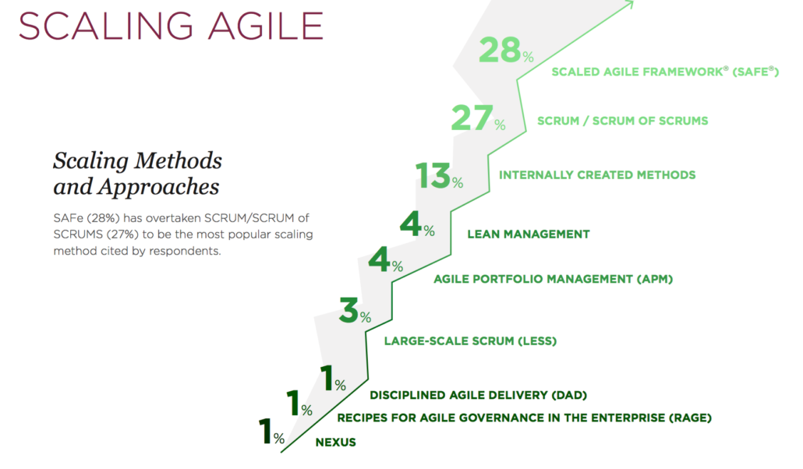  
(Van Drunen, n.d.).

The strategies shown in this picture have been followed by us in which step by step strategies were used to successfully complete the project.

# **Conclusion**

The essay aimed to undertake the research to demonstrate an understanding of the Agile concepts, tools and techniques for the launch of the digital product Master Mind Magic. The product is aimed to the audience aged between 8-12 years of age. The essay also discussed and demonstrated the core concepts of the agile methodology within the context of the business case study of Click-a-brick. The benefits of the agile PM plan are communicated through the business case to explain the response to a complex business of launching a mobile application need. The PM plan also aligned strategies to business priorities defined by the changing business requirements after every quarter. During the essay preparation, reflection on the agile process made the team to learn the complexity of a product launch and that how the team can make and implement iterations based on changing and evolving business needs. To mitigate the business needs of the product a collaborative strategy is implemented to embody the principles of the agile methodology.

.

**Appendix**

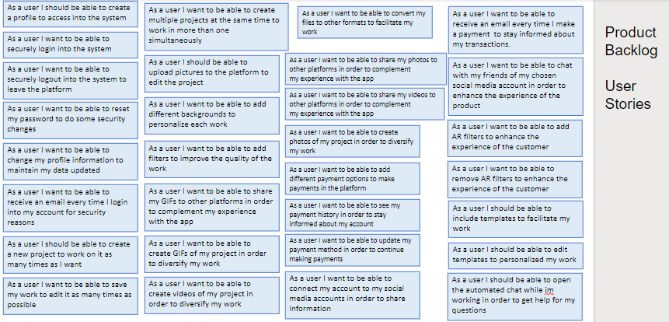

Sprint Week 1

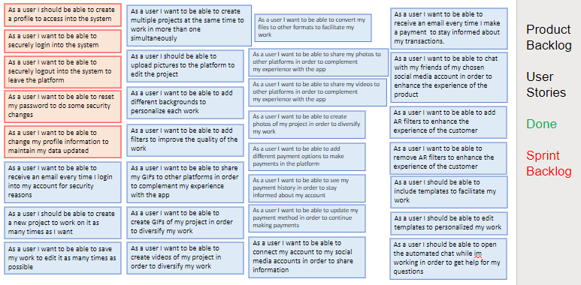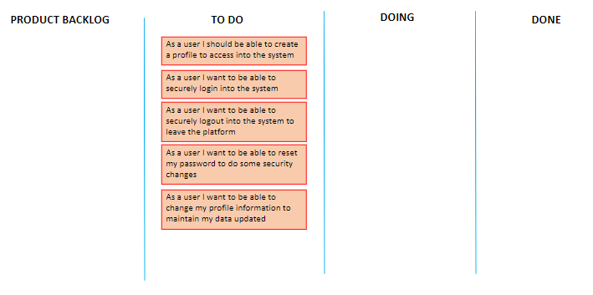

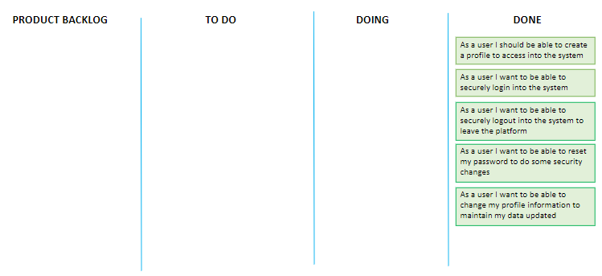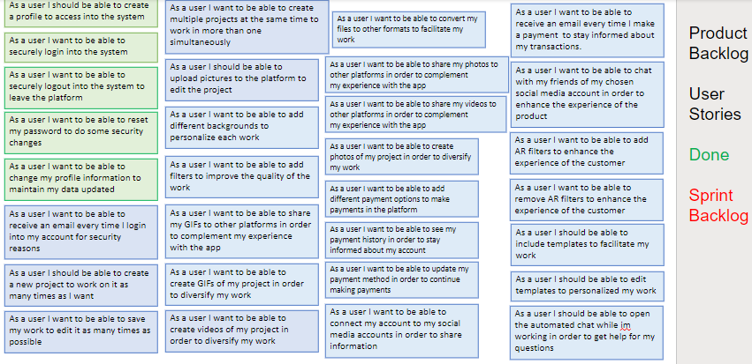

Sprint Week 2

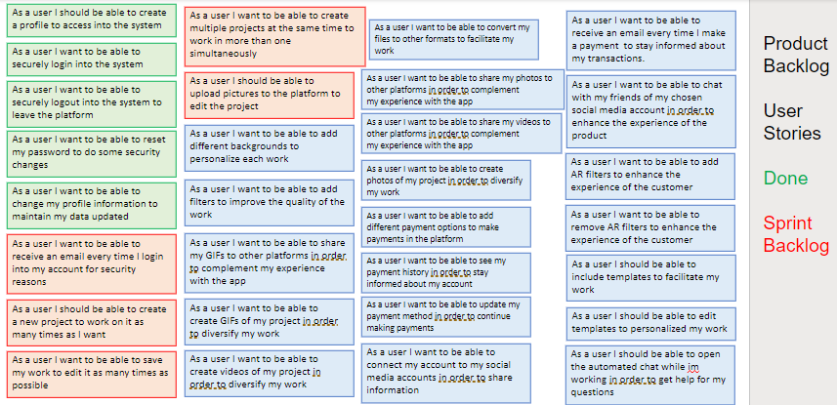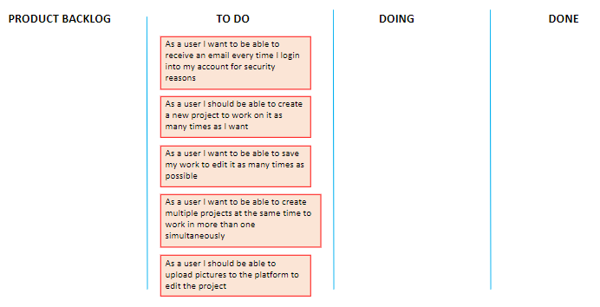

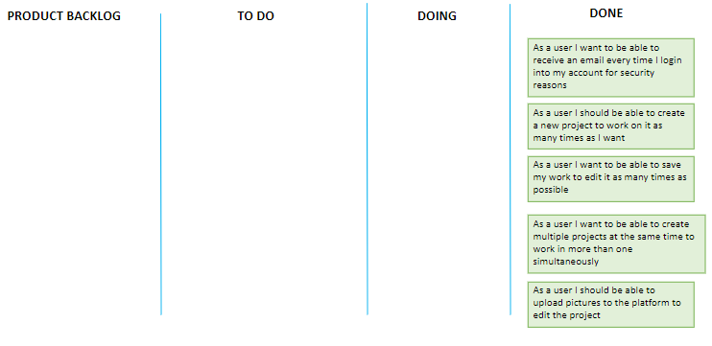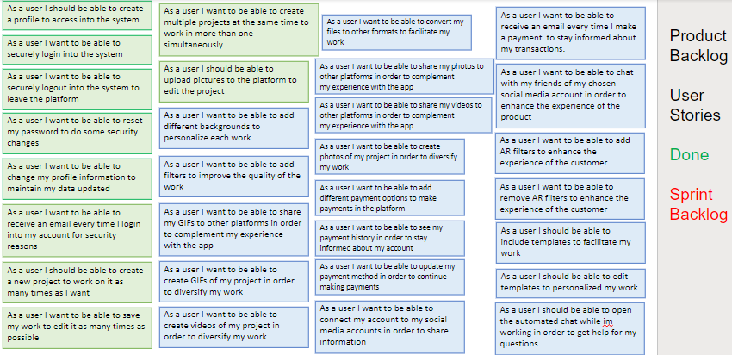

Sprint Week 3

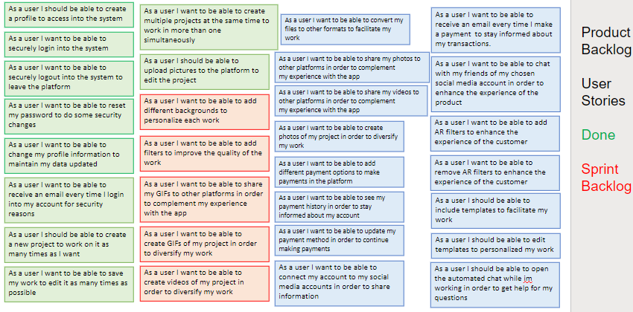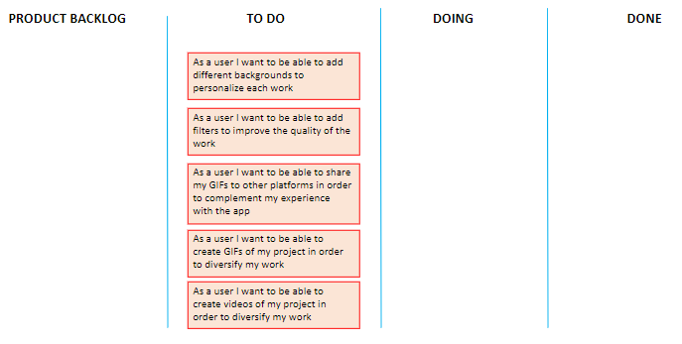

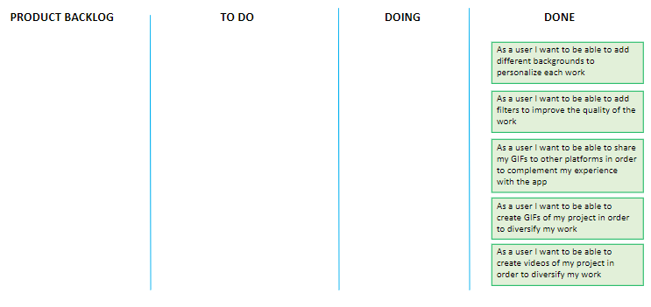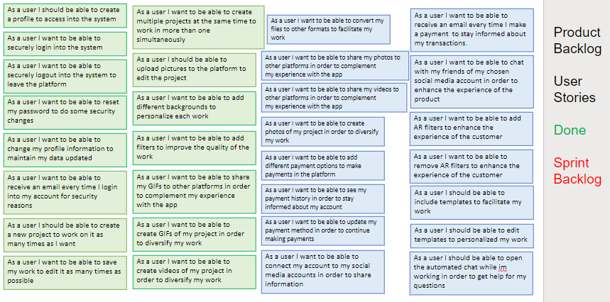

Sprint Week 4

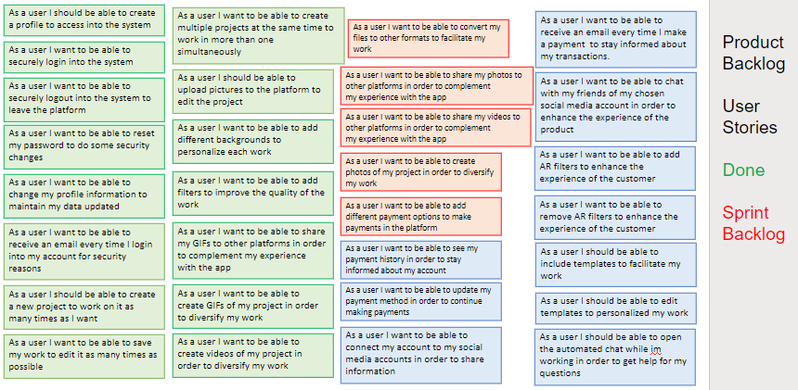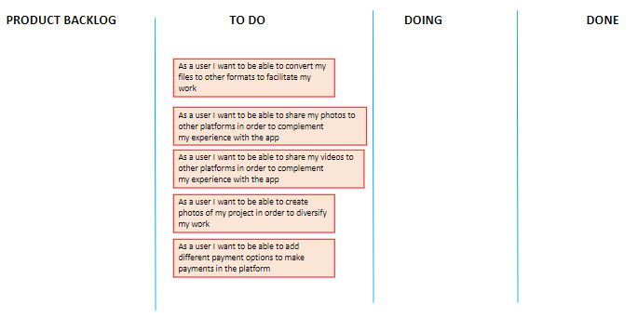

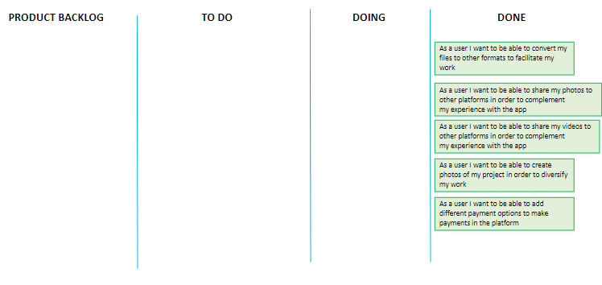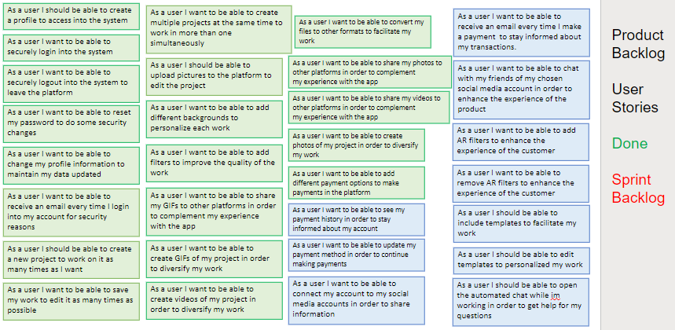

Sprint Week 5

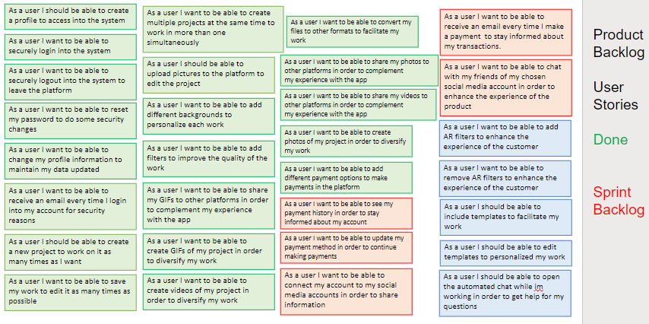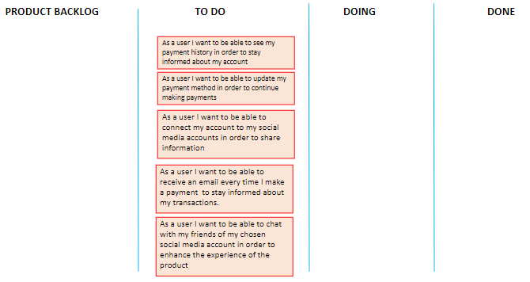

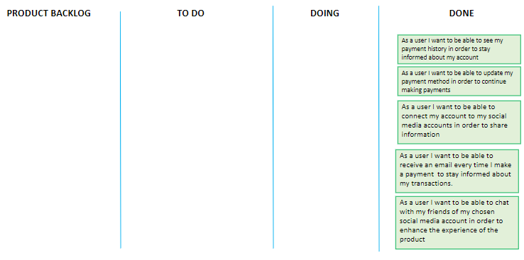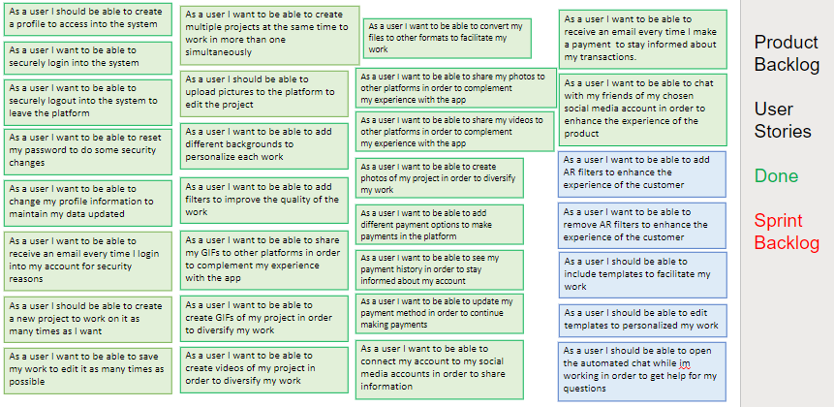

Sprint Week 6

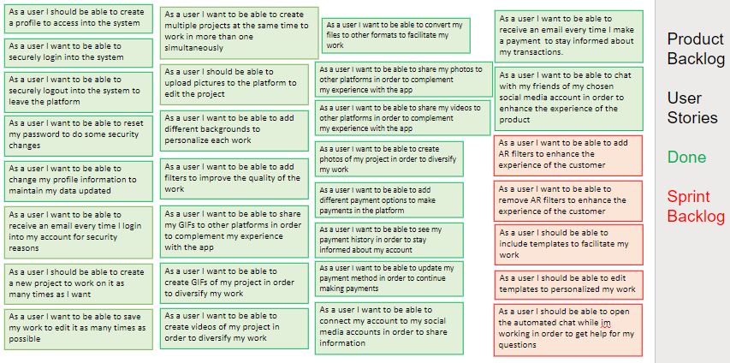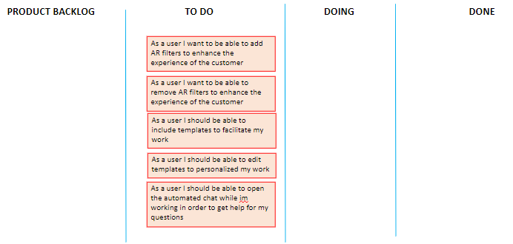

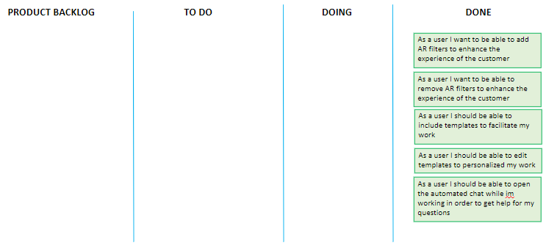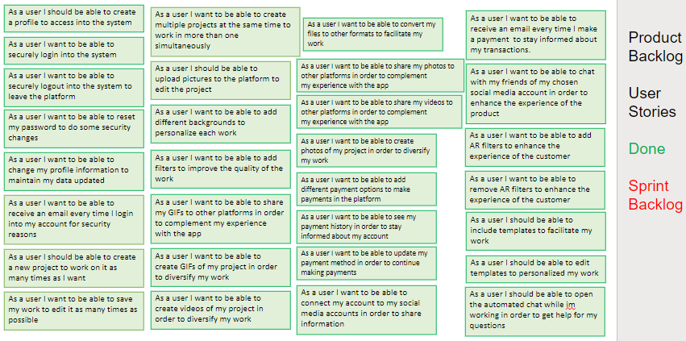

MVP

Home

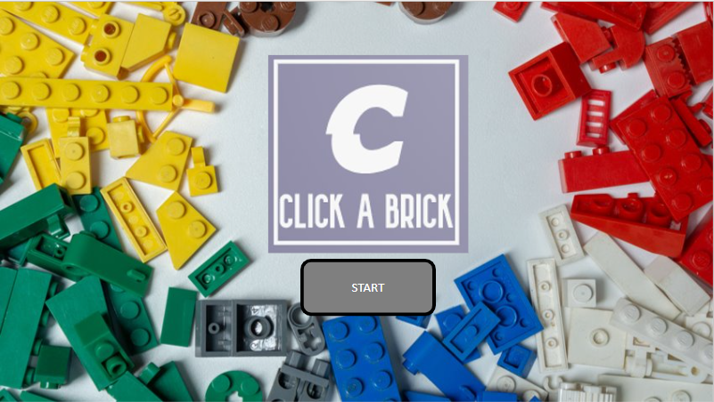

Sign Up

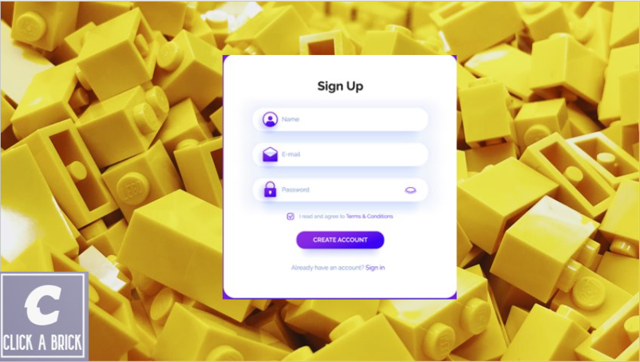

Login

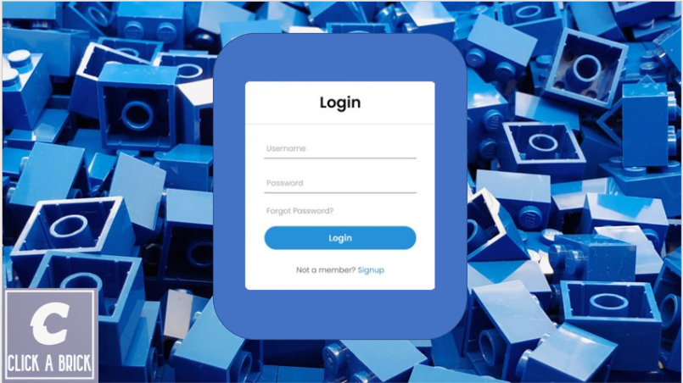

Profile

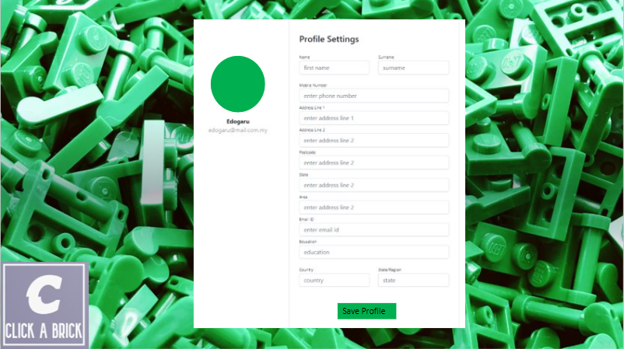

Create project

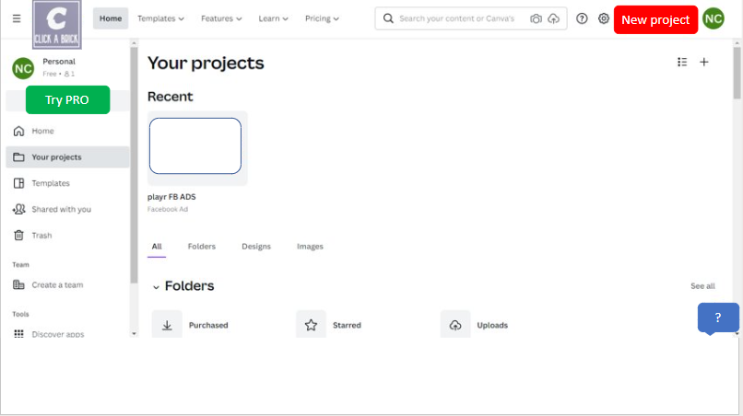

AR capabilities

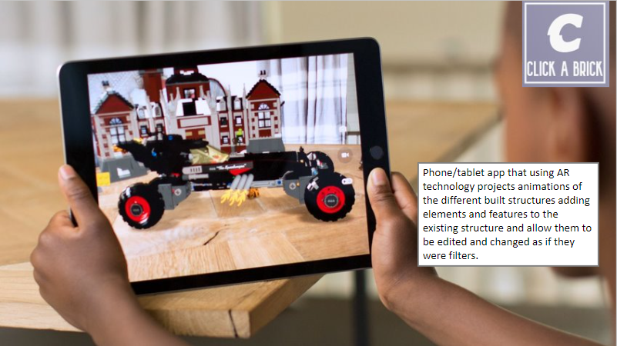

Functionalities

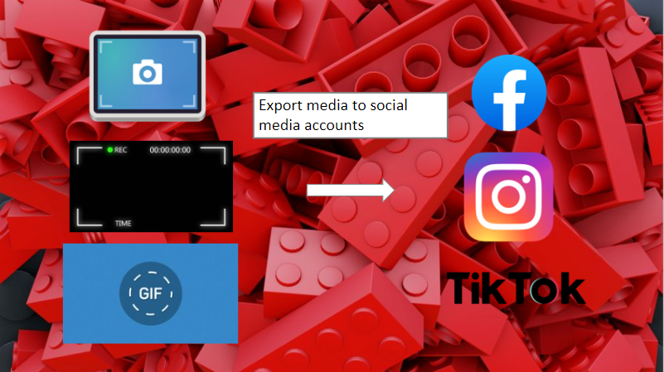

**Team Contract**

# **MIS608 Agile Project Management Assessment 3 - Team Contract**

**Introduction**

Agile project management relies on teams to work independently to achieve goals and objectives for the business. This relies on teams being clear on what is expected of participants as well as when and how it will be delivered. You will use the Agile Kanban framework and Kanban boards. The purpose of this team contract is to ensure that all team members are clear on what is expected of them for this assignment and to support the effective and successful working of the group to produce a high-quality report at the end of their group project. The group assignment is a substantial project and cannot be completed without all students in the group collaborating and working as a team.

1. It is expected that all students share ideas, points of view and do a fair and equitable allocation of the work required to complete the group project and report.
2. For the assignment to have a consistent strategy and have coherent continuity the team will need to work together over the course of the project to ensure that they produce a high-quality and well aligned report. Working independently and in silos and ‘stitching’ badly connected ideas together at the end does not achieve the same quality outcome.
3. The team contract must be completed, signed, and dated and the group must submit the completed group contract at the end of Week 3 at the start of the group project.
4. The team contract must also be attached to your group report as an appendix with any updates you may have made to the contract over the duration of your project.

# **Team member’s contact details**

The team will need to be able to contact each other throughout the course of this project. For this, you may wish to set up a WhatsApp chat group, a WeChat group or any other channels. This section needs to be completed immediately, in class, so that you have a means to contact each other.

|  |  |  |
| --- | --- | --- |
| **Name** | **Phone contact** | **Email/WeChat/Facebook/WhatsApp** |
| Harish Reddy Mekala | 0421745960 | Whatsapp |
| Ignacio Carreon Carrasco | 0488674558 | Whatsapp |
| Anjay Madiyal | 0402906026 | Whatsapp |
| Abhishek Saini  Hardik Patel  Mahesh Veldandi | 0420254435  0420536994  0423763554 | Whatsapp  Whatsapp  Whatsapp |

# **Ground-rules for meetings and communication**

The team will need to agree appropriate ways of contacting each other, turnaround times on communications and times when they may not be available need to be advised to the team. Mutual respect is key to building a good team spirit and this may influence your ground rules e.g. No calls after 10pm.

**Ground rules:** (To be completed by team)

1. Respect among teammates

2. Cooperation on equal terms

# **Team goals**

It is also vital for the team to know what each team member wants to achieve from the project.

One of the most common causes of conflict is when everybody assumes that they all want to same outcome on a project. Understandably, no one would ever say that they do not want a High Distinction. However not everybody has the same access to resources such as time and transport, and not everybody can make the same commitment to a project owing to different pressures in their schedule and there may be a need to set realistically achievable goals. It is good to understand each team member’s different expectations and then to draft team goals through consensus.

What does your team want to achieve, in order of priority? (To be completed by team)

**1 Complete the assessment in a timely manner**

**2 Achieve an outstanding grade**

**3 Learn more about Agile Methodology**

# **Team Project Backlog**

1. Planning is the key to success. Your group will have many competing priorities and assignments from other courses - to manage this you need to plan.
2. Plans sometimes need to change, but having a plan allows you to know what you need to change and what provisions you will need to make.

The team will define a backlog* of activities that need to take place and will ‘groom’ this backlog on a weekly basis to ensure that they are making steady progress towards their project goals.

**\*Backlog** – a prioritised list of all items that will need to be completed to achieve the goals of the project containing short descriptions of each item. Tasks should be allocated to a team member to ‘own’. They may not be the only person doing the task, but they will be responsible for ensuring it gets done. Each team member will have a backlog that they will ‘groom’ and move into ‘in progress’ at the appropriate time. Sometimes items may prove irrelevant and they can then be removed by team consent, or some items may arise that were not initially considered, and they should be added by team consent.

**Agreed time commitment per team member to project (hours per week):** _____1.5 hours_______________________

# **What will your role be?**

Suggested roles include: Scrum Master, Product Owner, Business Analyst, Research Analyst (To be completed by team)

|  |  |
| --- | --- |
| **Name** | **Role** |
| Harish Reddy Mekala | Product Owner |
| Mahesh Veldandi | Business Analyst |
| Anjay Madiyal  Ignacio Carreon Carrasco  Abhishek Saini  Hardik Patel | Research Analyst  Scrum Master  Business Analyst  Business Analyst |

# **Meeting Schedule**

It is recommended that the team has, as a minimum, weekly meeting to remain on track. These may be in the same physical location or using group call or shared platforms. From a timing perspective it is best to have this meeting at a time where you can prepare for your scrum and make the most up to date edits to your scrum board.

Expectations:

1. Attendance is expected at every meeting by every team member.
2. It is strongly advised that a standing time and venue is selected on completing this contract.
3. If any team member is unable to attend, they must advise the group as soon as possible to try and enable a reschedule, where possible for the other team members.
4. If a team member is absent, it is their responsibility to negotiate what work they need to do to contribute to the team’s weekly goals.
5. Each team member must be prepared for the meeting.
6. Respect must be shown for different cultures, languages and proficiencies and learning styles.

**Meeting schedule (in addition to meetings in class)** (To be completed by team)

|  |  |  |  |
| --- | --- | --- | --- |
| **Weeks** | **When (date/time)** | **Where** | **Preparation required** |
| **3** | After class | Whatsapp | Draft of the document |
| **4** | After class | Whatsapp | Draft of the document |
| **5** | After class | Whatsapp | Draft of the document |
| **6** | After class | Whatsapp | Draft of the document |
| **7** | After class | Whatsapp | Draft of the document |

# **Decision-making process**

**How will decisions be made – by consensus, majority vote, leader has final say etc.?**

Consensus

**How will you ensure that decisions are made in a timely way?**

Creating a Whatsapp group and defining roles and responsibilities.

# **Team expectations**

It is good to clarify what is and is not acceptable to the group:

Examples - you must document your own for your team:

1. No team member will be excluded from group activities
2. Late delivery and broken promises of delivery are not acceptable
3. All team members will contribute to discussions
4. Speak kindly, but honestly
5. Offer solutions

**Action to be taken by the team to address the issues listed above**

**1** Less contribution in report

**2** Exclusion from the team depending on the seriousness of the offense

**Other conditions or comments**

It is very important that every member of your team understands the details of the team contract and agrees to the specified rules and conditions.

# **Lecturer intervention**

These are times where the team may need to reach out to the lecturer for conciliation or mediation if the team cannot resolve the challenges on their own. It is worth mentioning that earlier intervention achieves better outcomes if there are challenges. In these instances, it is important to consider the following:

1. If work is not completed by a student, it may be classified as not contributing equally to the assignment.
2. The group may reach the conclusion that one or another student may have made an unequal contribution (done more, or less work than the others). In this instance, all students in the group will discuss the issue with the lecturer and it will be agreed that the student will receive a higher or lower mark than the other students in the group.

|  |  |  |  |
| --- | --- | --- | --- |
| **Date** | **Student name** | **Signature** | **Contribution %** |
| May 1, 2022 | Abhishek Saini | Abhishek Saini | 12 |
| May 1,2022 | Ignacio Carreon Carrasco | Ignacio Carreon Carrasco | 30 |
| May 1,2022 | Anjay Madiyal | Anjay Madiyal | 5 |

May 1,2022 Hardik Patel Hardik Patel 15

May 1,2022 Mahesh Veldandi Mahesh Veldandi 8

May 1,2022 Harish Reddy Mekala Harish Reddy Mekala 30

# **References**

Atlassian. (2022). *Product Roadmaps | Atlassian*. Atlassian. Retrieved 29 April 2022, from https://www.atlassian.com/agile/product-management/product-roadmaps#:~:text=What%20is%20a%20product%20roadmap,how%20they%20will%20be%20achieved.

Ghezzi, A. (2019). Digital startups and the adoption and implementation of Lean Startup Approaches: Effectuation, Bricolage and Opportunity Creation in practice. *Technological Forecasting And Social Change*, *146*, 945-960. https://doi.org/10.1016/j.techfore.2018.09.017

Herman, M. (2020). *The Key Principles Of Lean Startup Methodology - IdeaBuddy*. IdeaBuddy. Retrieved 29 April 2022, from https://ideabuddy.com/blog/lean-startup-methodology/.

Kuranov, A., & Tarashevska, A. (2022). *Top 6 Startup Agile project management tools to look at in 2020*. Massmediagroup.pro. Retrieved 29 April 2022, from https://massmediagroup.pro/blog-mmg/7-best-agile-project-management-tools-for-your-startup.

Lynn, R. (2022). *What is Velocity in Agile?*. Planview. Retrieved 29 April 2022, from https://www.planview.com/resources/articles/lkdc-velocity-agile/#:~:text=Velocity%20in%20Agile%20is%20a,iterations%2C%20sprints%2C%20or%20weeks.

Pichler, R. (2014). *8 Tips for Creating A Compelling Product Vision*. Roman Pichler. Retrieved 29 April 2022, from <https://www.romanpichler.com/blog/tips-for-writing-compelling-product-vision/#:~:text=The%20product%20vision%20is%20the,tough%2C%20and%20facilitates%20effective%20collaboration>.

Ortu, M., Murgia, A., Destefanis, G., Tourani, P., Tonelli, R., Marchesi, M., & Adams, B. (2016, May). The emotional side of software developers in JIRA. In *2016 IEEE/ACM 13th Working Conference on Mining Software Repositories (MSR)* (pp. 480-483). IEEE. Retrieved from <https://dl.acm.org/doi/pdf/10.1145/2901739.2903505?casa_token=GOpe4mcg0AUAAAAA:ignzZuw7d42PQ--nvnJzx3NvT4Eg7w1HaezoRv-QFRqZcx7NxlRV89MS5d0MqcDu36dCGAsNknrn>

Golfarelli, M., Rizzi, S., & Turricchia, E. (2012, September). Sprint planning optimization in agile data warehouse design. In *International Conference on Data Warehousing and Knowledge Discovery* (pp. 30-41). Springer, Berlin, Heidelberg.

Aguanno, K., & Schibi, O. (2018). *Agile business analysis: Enabling continuous*

*improvement of requirements, project scope, and agile project results*. USA: J. Ross Publishing. Retrieved from <https://ebookcentral-proquest-com.ezproxy.laureate.net.au/lib/think/reader.action?docID=5762202&ppg=215>

Cobb, C. G. (2015). *The project manager's guide to mastering agile: Principles and*

*practices for an adaptive approach*. New Jersey, USA: Wiley Retrieved from <https://ebookcentral-proquest-com.ezproxy.laureate.net.au/lib/think/reader.action?docID=1895876&ppg=131>

van Drunen, C. (n.d.). *Agile Report: SAFe #1 in Scaling Methods*. Qiqqer. <https://qiqqer.com/agile-report-safe-1-scaling-methods/?lang=en>